Task 5

Minimax Algorithm
The given values are
scores = [3, 5, 2, 9, 0, 7]
To complete the binary tree, we add two zeros at the end
[3, 5, 2, 9, 0, 7, 0, 0]
This makes the tree complete and helps us show Level 3 clearly in the diagram

Minimax Rules
MAX selects the largest value
MIN selects the smallest value
Image:
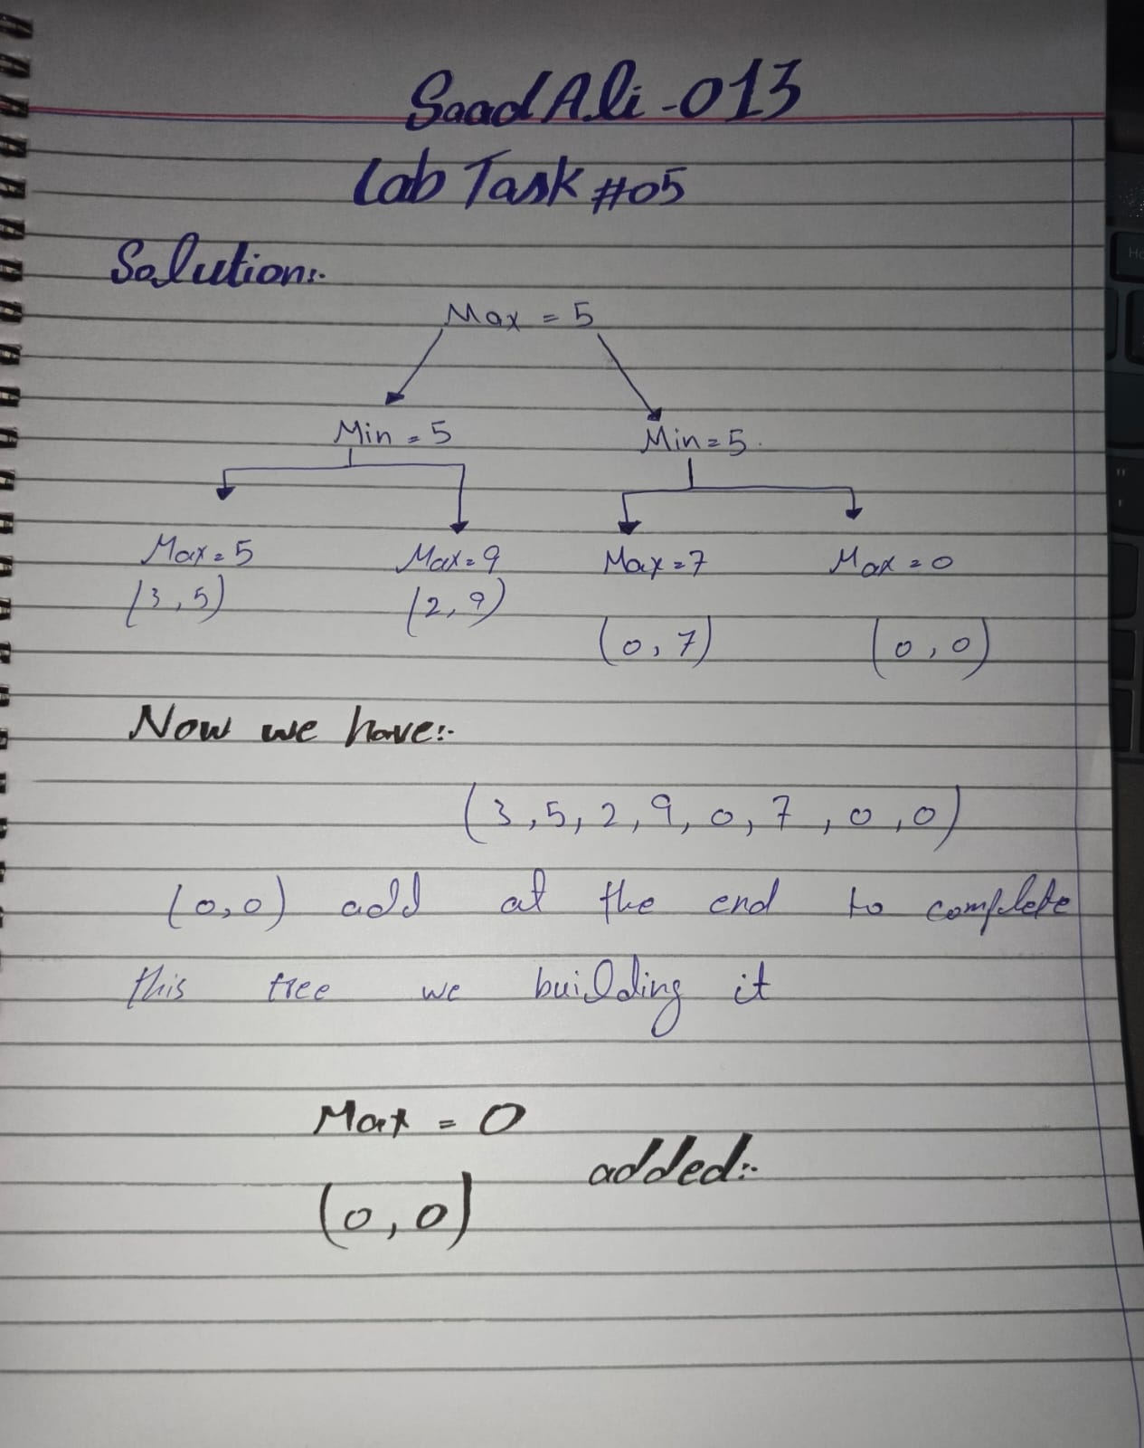

Level 1
At this point MAX selects the largest value from each pair
max(3, 5) = 5
max(2, 9) = 9
max(0, 7) = 7
max(0, 0) = 0

Level 2
At this level, MIN selects the smallest value from each pair
min(5, 9) = 5
min(7, 0) = 0

Level 3
At the root MAX selects the largest value from the two results
max(5, 0) = 5
Therefore, the final value of the root is 5

